OUR RECIPE!

TEAM 3
Cristian Esteban Ruiz Parra
Jim Alejandro Quiñones Martínez
Luis Ángel Martínez Cuenca
Javier Mateo Barrero Vanegas
LENGUA EXTRANJERA I CAI LE1-T1
Universidad de Cundinamarca
Rosa Delia Acosta
18-05.25

Cristian
Put on your apron.
Wash your hands.
Make the dough.
Roll out the dough into a round shape
Spread tomato sauce on top.
Put your toppings on.
Grate the cheese and sprinkle on top.
Place in the oven to cook.
When ready cut into slices and eat.

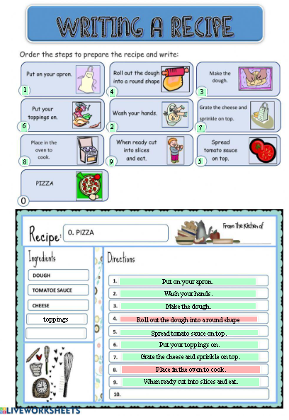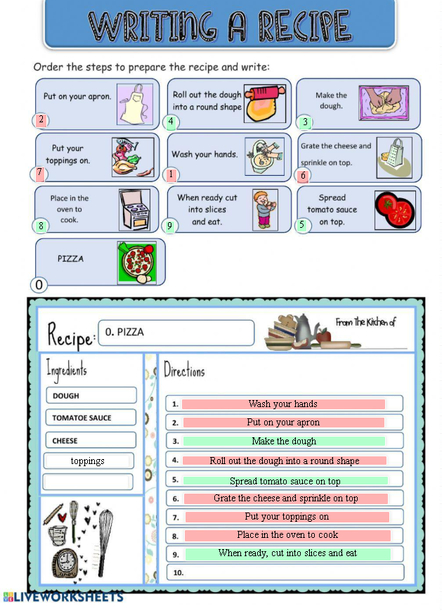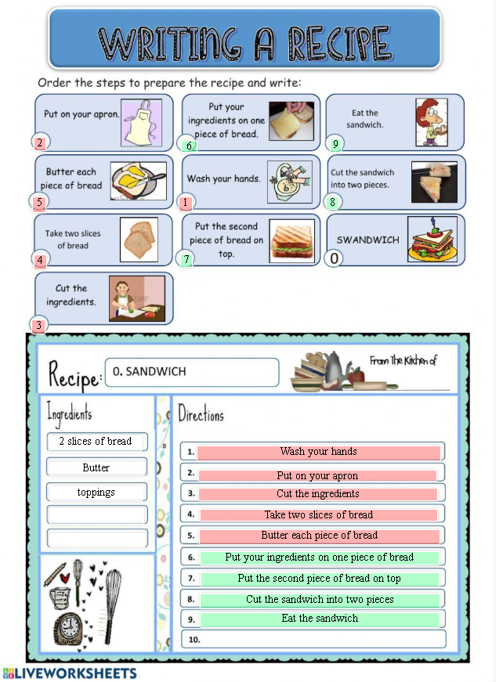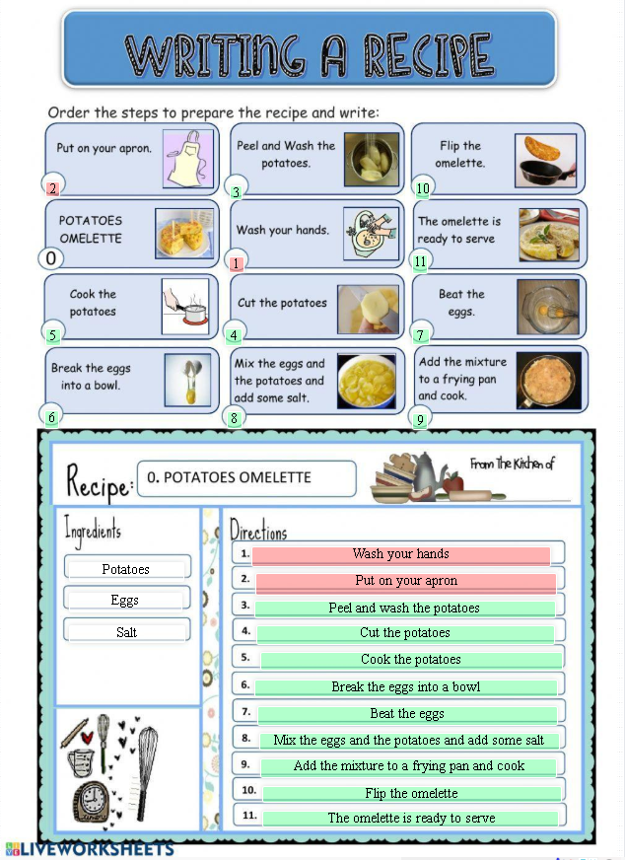
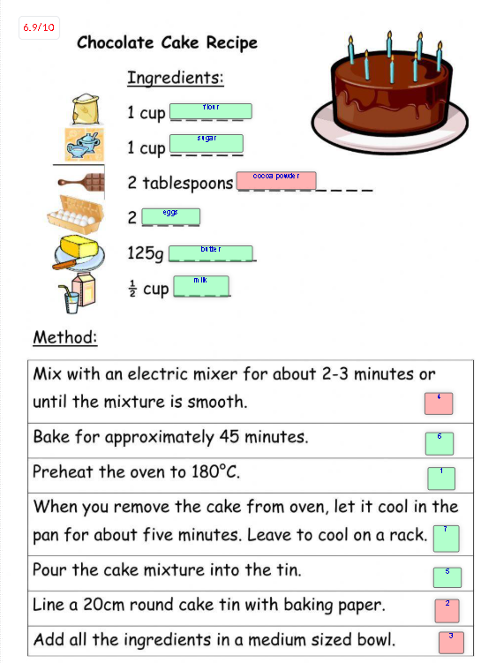
Jim

Mateo

Luis

Link Padlet
https://padlet.com/cristianeruizp281/our-recipe-dwczko2smvc1g0dm

